**CODE 3 SECURITY**

**APPLICATION AND BACKGROUND QUESTIONNAIRE**

CODE 3 SECURITY DATE:________________

POSITION_______________________________________________________________________

SECURITY OFFICER DISPATCHER SUPERVISOR ADMINSTRATION

This questionnaire will be used for reference by those who will be considering you for contract work or for a commission with CODE 3 SECURITY.

An extensive background investigation will be conducted into your personal history.

I understand that I will not receive, and I am not entitled to, a copy of the report or to know its contents. I further understand that the contents will be used in the evaluation process with CODE 3 SECURITY and that no documents submitted by me will be returned, and no copies of any other reports or documents utilized for or during my application will be furnished or given to me. Unless I am not selected based on a single test**, I WILL NOT BE ADVISED OF THE REASONS FOR NON-SELECTION.**

Where written explanations are required in this form, it is **MANDATORY** that the information be listed **TOTALLY AND COMPLETELY**.

**NOTE: Appropriate business attire is required for all steps of your processing, including all interviews and orientations. Failure to comply may result in removal from the hiring process.**

## CRITERIA STANDARDS FOR DISQUALIFICATION

1. ANY FELONY CONVICTION (NO TIME LIMIT)
2. PARTICIPATION IN ANY SERIOUS CRIME
3. ANY MISDEMEANOR CONVICTION INVOLVING NARCOTIC DRUGS OR DANGEROUS
4. ANY SELLING OF NARCOTICS DRUGS, OR DANGEROUS DRUGS
5. ANY RECENT ILLEGAL USE OF NARCOTICS OR DANGEROUS DRUGS
6. ANY EXCESSIVE ILLEGAL USE OF NARCOTICS OR DANGEROUS DRUGS IN YOUR LIFE
7. ANY HISTORY OF DISREGARD FOR TRAFFIC LAWS WITH SUCH FREQUENCY SO AS TO INDICATE A DISRESPECT FOR TRAFFIC LAWS AND A DISREGARD FOR THE SAFETY OF OTHER PERSONS ON THE HIGHWAY
8. ANY SEXUAL CONDUCT PROHIBITED BY LAW

PLEASE CONFIRM THAT YOU HAVE READ, UNDERSTAND, AND AGREE TO THE AFOREMENTIONED CONDITIONS AND CRITERIA BY SIGNING BELOW.

____________________________________________________

Applicant Signature Date

CODE 3 SECURITY

**AUTHORITY FOR RELEASE OF INFORMATION**



|  |  |  |  |  |  |  |  |  |  |  |  |
| --- | --- | --- | --- | --- | --- | --- | --- | --- | --- | --- | --- |
| **Last Name** |  | **First Name** | | **Middle Name** | **Sex** | **Race** | | | **Date of Birth** | | **SSN** |
|  |  |  | |  |  |  | | |  | |  |
|  | |  | |  |  |  | | | | |  |
| **City of Birth** | |  |  | **County** |  | |  | **State** | |  | **Country** |
|  | | |  | | | |  | | |  | |

I, _________________________________________________________, do hereby authorize a review of and full disclosure of all records, or any part thereof, concerning myself, by and to ANY duly authorized agent of CODE 3 SECURITY, Professional Standards Section, whether said records are of public, private, or confidential nature.

The intent of this authorization is to give my consent for full and complete disclosure of the records of educational institutions; employment and pre-employment records, including background reports, efficiency ratings, complaints or grievances filed by or against me, and salary records; records of complaint, arrest, trial, and/or convictions for alleged or actual violations of law, including criminal, civil, and/or traffic records; the results of any polygraph examinations; records of complaints of a civil nature made by or against me, wherever located, including the records and recollections of attorneys at law, or of other counsel, whether representing me or another person in any case in which I presently have or have had an interest.

I reiterate and emphasize that the intent of this authorization is to provide full and unobstructed access to the background and history of my personal life for the specific purpose of pursuing a background investigation, which may provide pertinent data to CODE 3 SECURITY to consider in determining my suitability for employment by that department. It is my specific intent to provide access to personal information, however personal or confidential it may appear to be, and the sources of information specifically identified herein.

I understand that any information obtained by a personal history background investigation, which is developed directly or indirectly, in whole or in part, upon this release authorization will be considered in determining my suitability for employment by CODE 3 SECURITY. I understand that all materials pertaining to this background investigation become the property of CODE 3 SECURITY, Professional Standards Section, and will not be returned to me.

I agree to indemnify and hold harmless the person to whom this request is presented and his agents and employees, from and against all claims, damages, losses, and expenses, including reasonable attorney’s fees, arising out of or by reason of complying with this request. I further understand that in the event my application is disapproved, the sources of confidential information cannot be revealed to me.

A photocopy of this release form will be valid as an original hereof, even though said photocopy does not contain an original writing of my signature.

***Note:* Where necessary, use a separate page to complete answers throughout this questionnaire.**

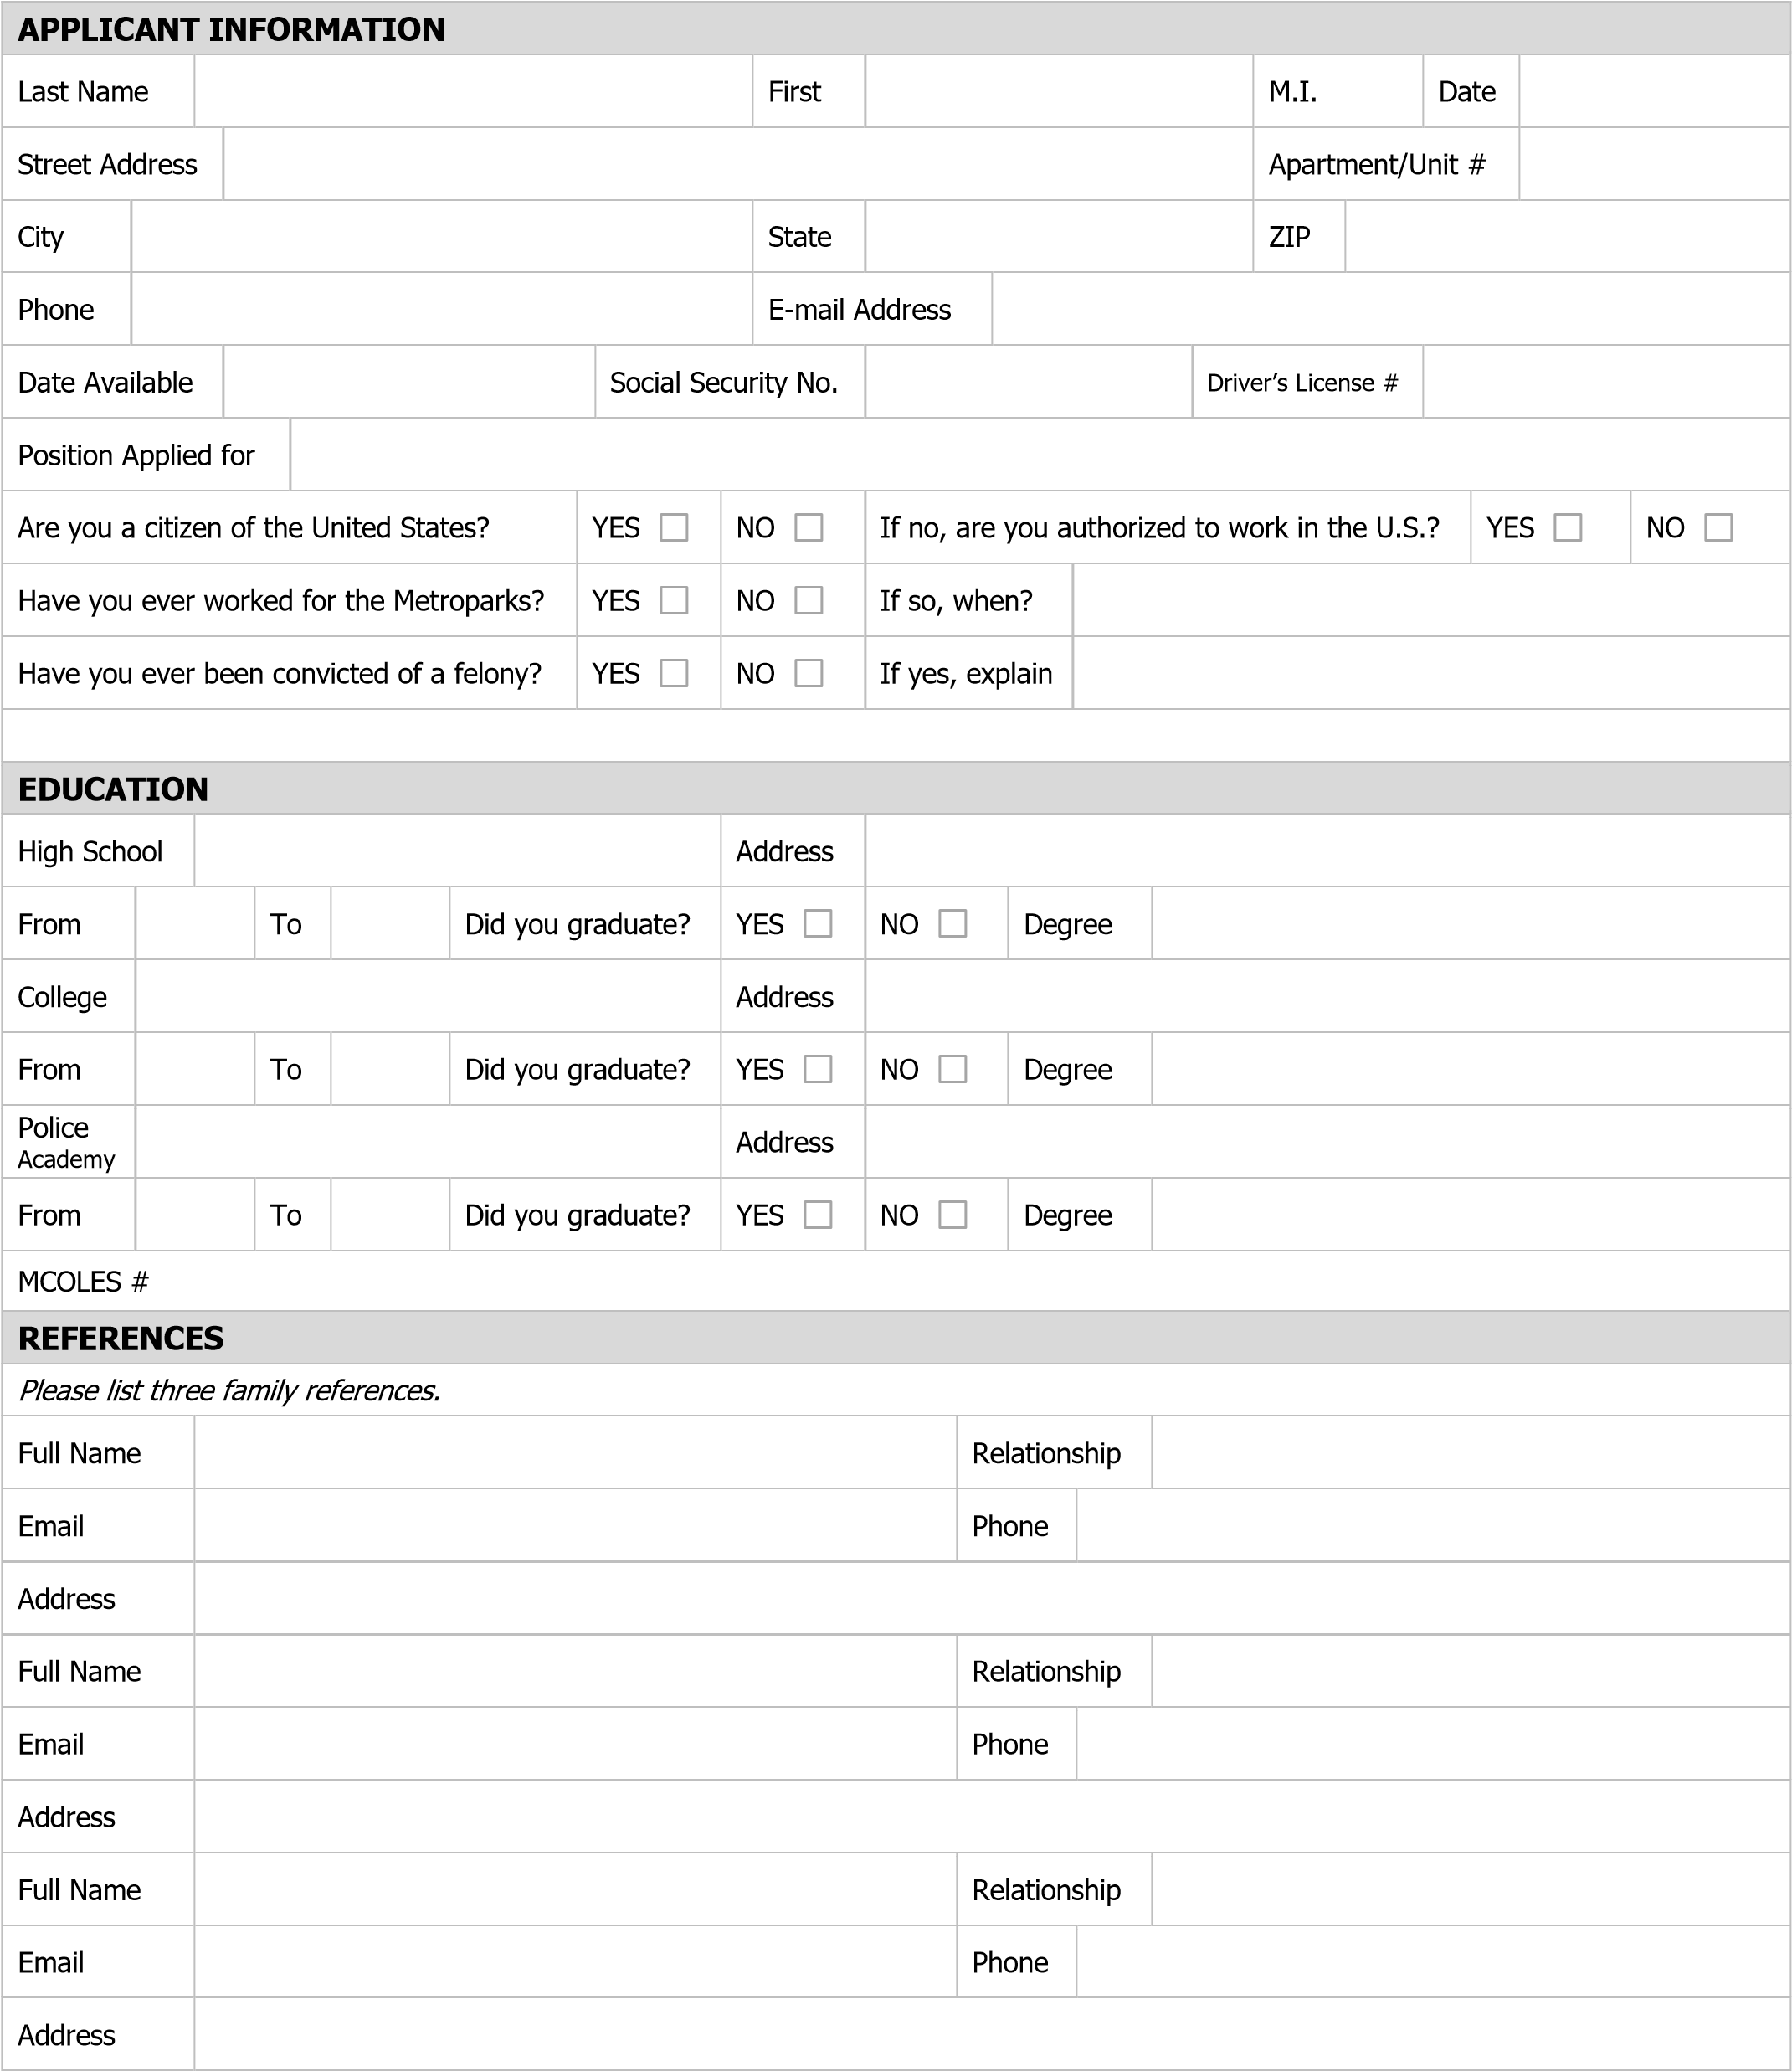

|  |  |  |  |  |  |  |  |  |
| --- | --- | --- | --- | --- | --- | --- | --- | --- |
| **REFERENCES** | |  | | | | | | |
| Please list three personal references. | |  | | | | | | |
| Full Name |  | Relationship | |  | | | | |
| Email |  | Phone |  | | | | | |
| Address |  |  | | | | | | |
| Full Name |  | Relationship | |  | | | | |
| Email |  | Phone |  | | | | | |
| Address |  |  | | | | | | |
| Full Name |  | Relationship | |  | | | | |
| Email |  | Phone |  | | | | | |
| Address |  |  | | | | | | |
|  |  |  | | | | | | |
|  |  |  | | | | | | |
| **REFERENCES** | |  | | | | | | |
| Please list three professional references. | |  | | | | | | |
| Full Name |  | Relationship | |  | | | | |
| Company |  | Phone |  | | | | | |
| Address |  |  | | | | | | |
| Full Name |  | Relationship | |  | | | | |
| Company |  | Phone |  | | | | | |
| Address |  |  | | | | | | |
| Full Name |  | Relationship | |  | | | | |
| Company |  | Phone |  | | | | | |
| Address |  |  | | | | | | |
| **QUESTIONNAIRE** | |  | | | | | | |
| Do you have a valid Concealed Pistol License? If yes, list license number: | | | | | ◻ | Yes | ◻ | No |
|  | | | | |  |  |  |  |
| Have you ever been terminated or asked to resign from any employment? If yes, explain. | | | | | ◻ | Yes | ◻ | No |
|  | | | | |  |  |  |  |
| Have you ever resigned from a job to avoid being fired or terminated? | | | | | ◻ | Yes | ◻ | No |
|  | | | | |  |  |  |  |
| Have you been tardy or late for work because of circumstances within your control? If yes, how often? | | | | | ◻ | Yes | ◻ | No |
|  | | | | |  |  |  |  |
| Have you ever been written up, counseled, or disciplined in any manner, by any of your employers for failure to comply with required rules or regulations, or for any other reason? If yes, explain. | | | | | ◻ | Yes | ◻ | No |
|  | | | | |  |  |  |  |
| Have you ever quit a job without giving notice required by an employer? If yes, explain. | | | | | ◻ | Yes | ◻ | No |
|  | | | | |  |  |  |  |
| Have you ever had a warrant issued for your arrest for failure to pay a citation or failure to appear in court? If yes, explain. | | | | | ◻ | Yes | ◻ | No |
|  | | | | |  |  |  |  |
| Have you had the police to your residence for any reason? If yes, explain. | | | | | ◻ | Yes | ◻ | No |
|  | | | | |  |  |  |  |
| Do you currently have automobile insurance as mandated by the state? If no, explain why not | | | | | ◻ | Yes | ◻ | No |
|  | | | | |  |  |  |  |
| Have you ever attended a driver improvement school? If yes, explain. | | | | | ◻ | Yes | ◻ | No |
|  | | | | |  |  |  |  |
| Are you aware that the employment environment within this agency is a DRUG-FREE ENVIRONMENT, and any violation of that policy can lead to termination? | | | | | ◻ | Yes | ◻ | No |
|  | | | | |  |  |  |  |

|  |  |  |  |  |  |
| --- | --- | --- | --- | --- | --- |
| **PREVIOUS EMPLOYMENT**  List all places of employment. Begin with present or most recent employer and go backwards. List periods of school, military service, and unemployment in the past 3 years. List everything in proper sequence, leaving no vacant time lapse. Do not omit any employers. | | | | | |
| Company | | | Phone |  |  |
| Address | | | Supervisor |  |  |
| Job Title | | Starting Salary | $ | Ending Salary | $ |
| Responsibilities | | |  |  |  |
| From To | Reason for Leaving | |  |  |  |
| May we contact your previous supervisor for a reference? YES | | | NO |  |  |
| Company | | | Phone |  |  |
| Address | | | Supervisor |  |  |
| Job Title | | Starting Salary | $ | Ending Salary | $ |
| Responsibilities | | |  |  |  |
| From To | Reason for Leaving | |  |  |  |
| May we contact your previous supervisor for a reference? YES | | | NO |  |  |
| Company | | | Phone |  |  |
| Address | | | Supervisor |  |  |
| Job Title | | Starting Salary | $ | Ending Salary | $ |
| Responsibilities | | |  |  |  |
| From To | Reason for Leaving | |  |  |  |
| May we contact your previous supervisor for a reference? YES | | | NO |  |  |

|  |  |
| --- | --- |
| **MILITARY SERVICE** |  |
| Branch | From To |
| Rank at Discharge | Type of Discharge |
| If other than honorable, explain |  |

|  |
| --- |
| Are you currently active with any Military Reserves? Explain  How often?  List any specialty training. |

**EMPLOYMENT INFORMATION**

|  |  |  |  |  |
| --- | --- | --- | --- | --- |
| Have you ever been disciplined in any of your pervious employment? If yes, explain. | ◻ | Yes | ◻ | No |
|  |  |  |  |  |
| Have you had any extended work absences not related to vacations? If yes, explain. | ◻ | Yes | ◻ | No |
|  |  |  |  |  |
| Are you an owner or partner in a business? If yes, explain. | ◻ | Yes | ◻ | No |
|  |  |  |  |  |
| Have you been discharged or asked to resign from any employment? If yes, explain. | ◻ | Yes | ◻ | No |
|  |  |  |  |  |
|  |  |  |  |  |
| **LEGAL** |  |  |  |  |

|  |  |  |  |  |
| --- | --- | --- | --- | --- |
| Have you ever been arrested? If yes, explain. | ◻ | Yes | ◻ | No |
|  |  |  |  |  |
| Have you ever been convicted of a misdemeanor or felony? If yes, explain. | ◻ | Yes | ◻ | No |
|  |  |  |  |  |
| Have you ever been investigated or implicated in a criminal case? If yes, explain. | ◻ | Yes | ◻ | No |
|  |  |  |  |  |
| Have you ever had a conviction expunged from your records either as an adult or juvenile? If yes, explain. | ◻ | Yes | ◻ | No |
|  |  |  |  |  |
| Do you have an assumed name/maiden name/name change? List. | ◻ | Yes | ◻ | No |
| **PERFORMANCE OF DUTY** |  |  |  |  |

|  |  |  |  |  |
| --- | --- | --- | --- | --- |
| If it became necessary to take a life in the line-of-duty, would religious or personal beliefs affect you? If yes, explain. | ◻ | Yes | ◻ | No |
|  |  |  |  |  |
| Are there any religious or other beliefs that would prevent you from fulfilling your duties as an Officer? If yes, explain. | ◻ | Yes | ◻ | No |
|  |  |  |  |  |
| Have you ever been shot or seriously injured? If yes, explain. | ◻ | Yes | ◻ | No |
|  |  |  |  |  |
| Have you ever shot or seriously injured anyone? If yes, explain. | ◻ | Yes | ◻ | No |

|  |  |  |
| --- | --- | --- |
| **TRAFFIC** | |  |
| Date & Offense | Jurisdiction | Disposition |
|  |  |  |
|  |  |  |
|  |  |  |
|  |  |  |
|  |  |  |
|  |  |  |
|  |  |  |
|  |  |  |
| **LIST ALL FIREARMS THAT YOU POSSESS** | |  |
| Type | Make/Model | Caliber |
|  |  |  |
|  |  |  |
|  |  |  |
|  |  |  |
|  |  |  |
|  |  |  |
|  |  |  |
| **GENERAL INFORMATION** | |  |

|  |  |  |  |  |
| --- | --- | --- | --- | --- |
| Do you speak or understand any other language? If yes, list. | ◻ | Yes | ◻ | No |
|  |  |  |  |  |
| Have you or do you use marijuana or other drug(s) not prescribed by a physician? If yes, explain | ◻ | Yes | ◻ | No |
|  |  |  |  |  |
| Do you drink alcohol and/or smoke cigarettes? If yes, how frequent. | ◻ | Yes | ◻ | No |
| Do you have a problem with assisting someone with a communicable disease? (HIV/AIDS, hepatitis, Ebola, TB, etc.) | ◻ | Yes | ◻ | No |
| Have you ever been involved with the sale of illegal drugs, property or concealment of drugs or property? If yes, explain. | ◻ | Yes | ◻ | No |
|  |  |  |  |  |
| **PERSONAL** |  |  |  |  |

|  |  |  |  |  |
| --- | --- | --- | --- | --- |
| List any scars, marks and/or tattoos. Indicate the location. |  |  |  |  |
|  |  |  |  |  |
| Provide the last (4) four residences. (Dates there/address/city/state) |  |  |  |  |
|  |  |  |  |  |
|  |  |  |  |  |
|  |  |  |  |  |
|  |  |  |  |  |
| Have any promises been made in your securing a position with Code 3 Security? If yes, explain. | ◻ | Yes | ◻ | No |
|  |  |  |  |  |

**REQUIRED PAPERWORK**

You are to provide clear copies or originals of the below listed information:

|  |  |
| --- | --- |
| ◻ | Birth Certificate |
| ◻ | Social Security Card |
| ◻ | Michigan Operators License |
| ◻ | High School or GED Certificate |
| ◻ | Michigan Concealed Pistol License |

|  |
| --- |
| **DISCLAIMER AND SIGNATURE** |
| I certify that my answers are true and complete to the best of my knowledge. I understand that withholding information or making false statements on this form will be the basis for immediate disqualification from consideration of employment or dismissal after appointment. I understand that any appointment offered will be contingent upon Code 3 Security final disposition based on a complete character and fitness evaluation. |
| Print Name |
| Signature Date |
| Witnessed by C3S Supervisor Date only |